**Pizza Sales SQL Queries**

**KPI’s**

1. **Total Revenue:**

SELECT SUM(total_price) AS Total_Revenue from pizza_sales

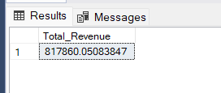

1. **Average Order Value:**

SELECT SUM(total_price)/ COUNT(DISTINCT(order_id)) as Avg_Order_Value from pizza_sales

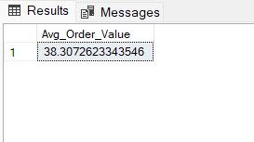

1. **Total Pizza’s Sold:**

SELECT SUM(quantity) as Total_Pizza_Sold from pizza_sales

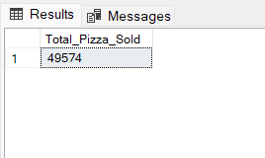

1. **Total Orders Placed:**

SELECT COUNT(DISTINCT(order_id)) as Total_Orders_Placed from pizza_sales

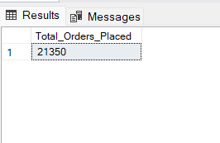

1. **Average Pizzas Per Order:**

SELECT CAST(CAST(SUM(quantity) AS decimal(10,2)) /

CAST(COUNT(DISTINCT(order_id)) AS decimal(10,2)) AS DECIMAL(10,2)) as AVG_Pizza_per_order from pizza_sales

**Chart Requirements**

1. **Daily Trend for Total Orders:**

SELECT DATENAME(DW, order_date) as order_day, COUNT(DISTINCT order_id) as Total_Orders

From pizza_sales

GROUP By DATENAME(DW, order_date)

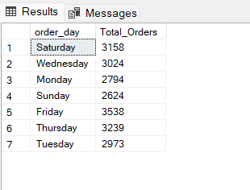

1. **Monthly Trend For Total Orders:**

SELECT DATENAME(Month, order_date) as Month_day, COUNT(DISTINCT order_id) as Total_Orders

From pizza_sales

GROUP BY DATENAME(Month, order_date)

ORDER BY COUNT(DISTINCT order_id) DESC

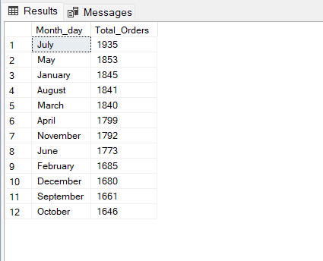

1. **Percentage of Sales By Pizza Category:**

SELECT pizza_category, SUM(total_price) AS Total_sales, SUM(total_price) * 100/

(SELECT SUM(total_price) from pizza_sales WHERE MONTH(order_date) = 1) AS Perc_Total_Sales

FROM pizza_sales

WHERE MONTH(order_date) = 1

GROUP BY pizza_category

1. **Percentage of Sales By Pizza Size:**

SELECT pizza_size, CAST(SUM(total_price) AS DECIMAL (10,2)) AS Total_sales, CAST(SUM(total_price) * 100/

(SELECT SUM(total_price) from pizza_sales WHERE DATEPART(quarter,order_date) = 1) AS DECIMAL(10,2)) AS Perc_Total_Sales

FROM pizza_sales

WHERE DATEPART(quarter,order_date) = 1

GROUP BY pizza_size

ORDER BY Perc_Total_Sales DESC

1. **Top 5 Pizza Based On Revenue:**

SELECT TOP 5 pizza_name, SUM(total_price) as Total_Revenue from pizza_sales

GROUP BY pizza_name

ORDER BY Total_Revenue DESC

1. **Bottom 5 Pizza Based On Revenue:**

SELECT TOP 5 pizza_name, CAST(SUM(total_price) AS DECIMAL(10,2)) as Total_Revenue from pizza_sales

GROUP BY pizza_name

ORDER BY Total_Revenue

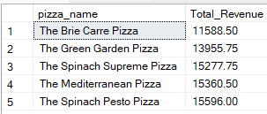

1. **Top 5 Pizza Based On Quantity:**

SELECT TOP 5 pizza_name, SUM(quantity) as Total_Quant from pizza_sales

GROUP BY pizza_name

ORDER BY Total_Quant DESC

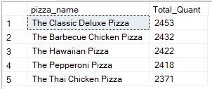

1. **Bottom 5 Pizza Based On Quantity:**

SELECT TOP 5 pizza_name, SUM(quantity) as Total_Quant from pizza_sales

GROUP BY pizza_name

ORDER BY Total_Quant

